ShopSphere: Marketing, Category & Customer Analytics
A data-driven review of marketing efficiency, category profitability, customer economics and the checkout redesign experiment (2022-2024).
Prepared by Volodymyr Holovan
Interactive dashboard (Tableau Public): https://public.tableau.com/views/ShopSphereBusinessAnalysis/Dashboard1?:language=en-US&publish=yes&:sid=&:redirect=auth&:display_count=n&:origin=viz_share_link
Data & code (GitHub): https://github.com/volodymyr-holovan/shopSphere_project/tree/main

Dashboard narrative

Question 1. What story does the dashboard tell, top to bottom, and why that order?
Answer
The dashboard opens with headline KPIs so a reader immediately knows the scale of the business, then moves from the general to the specific, and closes on the two levers leadership can actually pull. Row 1 shows total revenue, order count, average order value and return rate as KPI cards. Row 2 shows revenue by region over time, answering "where is the business today and where is it heading." Row 3 zooms into customers and categories: the top 10 customers by spend, and the category profitability map that separates genuine profit drivers from volume-only categories. Row 4 closes on marketing ROI versus budget allocation by channel — the one view that converts every insight above into a concrete budget decision. The order mirrors how an executive actually reasons: context, then trend, then drivers, then the decision.
Question 2. What three insights should a reader catch in the first 30 seconds?
- A small customer base carries the business: 862 customers (about 29% of the base) already generate 72.7% of total revenue — see the KPI cards below.
- Growth is shifting away from the historical center of gravity: North America and Southeast Asia have overtaken Europe's growth rate since 2023, while Europe's trend line is flattening.
- Budget and ROI are pointing in opposite directions: Paid Search absorbs the largest share of marketing budget ($450,959) while returning the lowest ROI (1.3x) of any channel.
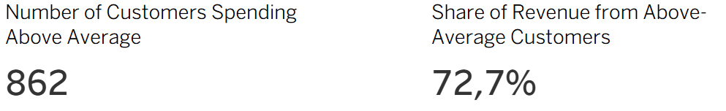
Above-average customer KPIs, as shown on the dashboard.
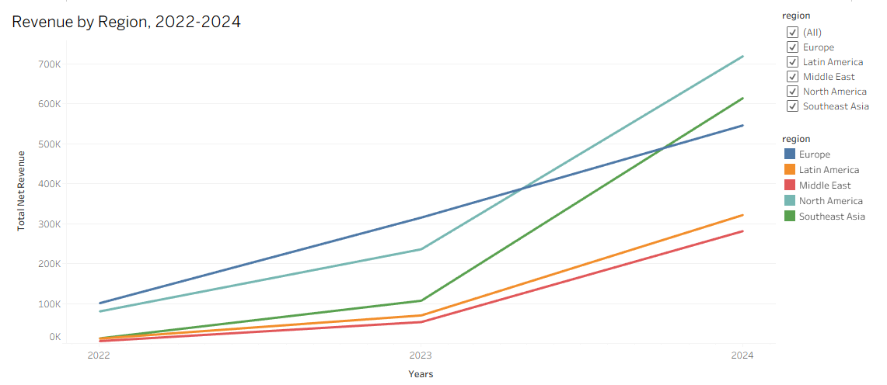
Figure. Revenue by region, 2022-2024 — Southeast Asia and North America are now outpacing Europe.

Case A. Where should the marketing budget go?

Question 3. Which channel delivers the best ROI? The worst? Where does the budget currently go, and is that sensible?
Conclusion
Organic and Email deliver the best return on marketing spend, while Paid Search delivers the worst — yet Paid Search absorbs almost half of the entire marketing budget. The current allocation is not aligned with channel performance.
Supporting numbers
- ROI by channel (attributed revenue / budget): Organic 8.02x, Email 6.50x, Influencer 4.62x, Referral 3.57x, Social Ads 2.06x, Paid Search 1.33x.
- Budget allocation: Paid Search 46.0% ($450,959), Social Ads 29.2% ($286,488), Influencer 11.4%, Referral 7.5%, Email 3.8%, Organic 2.1%.
- The two lowest-ROI channels (Paid Search, Social Ads) absorb 75.2% of the total marketing budget combined.
Visualization
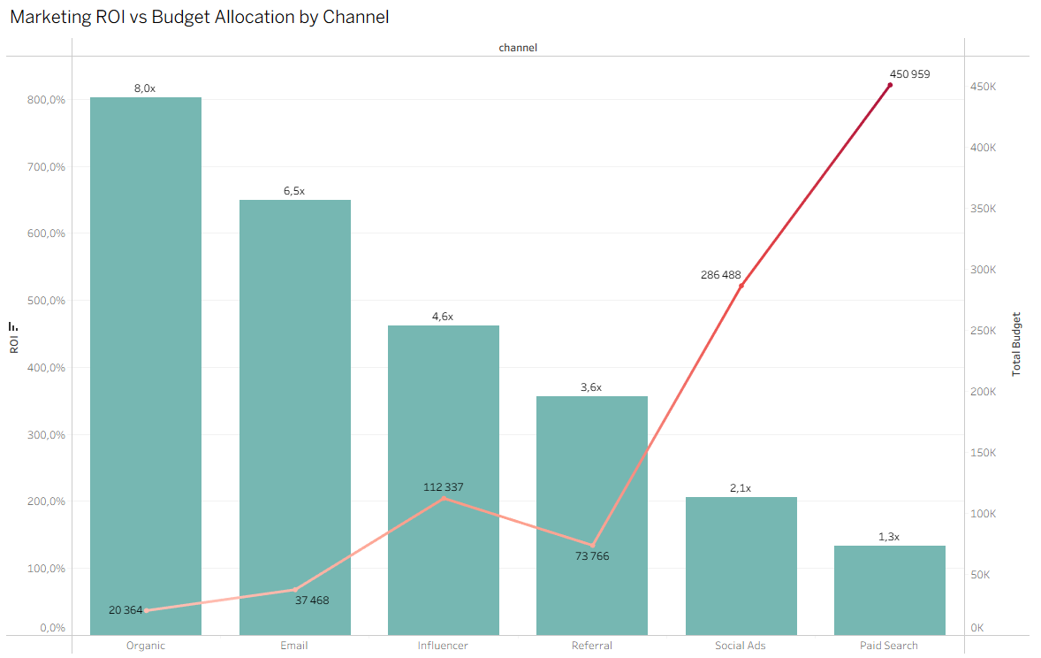
Figure. Marketing ROI vs. budget allocation by channel. The highest bar (best ROI) has the smallest budget footprint; the lowest bar (worst ROI) has the largest.
Recommendation
Budget allocation should track ROI, not habit or channel size. Paid Search is the strongest candidate for a spend reduction test.

Question 4. How do channels compare on long-term customer value (LTV), not just campaign ROI? Does the ranking match?
Conclusion
The rankings only partly agree. Paid Search is worst on both campaign ROI and customer LTV — a consistent signal to cut. But Influencer, which ranks third on campaign ROI, produces the single highest-LTV customers, while Organic — the top channel on campaign ROI — only ranks third on LTV. Campaign ROI measures the value of a single sale; LTV measures the value of the relationship.
Supporting numbers
- Average LTV (total historical spend) by acquisition channel: Influencer $1,985.73 (357 customers), Referral $1,791.82 (266), Organic $1,316.13 (721), Email $1,074.46 (372), Social Ads $822.09 (619), Paid Search $648.10 (665).
- Campaign-ROI ranking: Organic > Email > Influencer > Referral > Social Ads > Paid Search.
- LTV ranking: Influencer > Referral > Organic > Email > Social Ads > Paid Search.
- Paid Search and Social Ads are the bottom two on both metrics; Influencer and Referral are the top two specifically on LTV.
Visualization
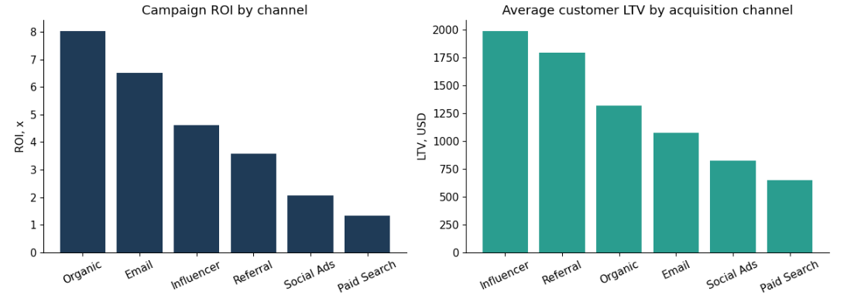
Figure. Campaign ROI by channel (left) versus average customer LTV by acquisition channel (right).
Recommendation
Use campaign ROI to judge short-term efficiency and LTV to judge who is worth acquiring. Influencer and Referral deserve extra weight in the budget decision because they win on the metric that compounds — customer lifetime value.

Question 5. How should the budget be reallocated? What are the risks of this recommendation?
Conclusion
Shift budget away from Paid Search — and moderately away from Social Ads — toward Influencer, Referral, Organic and Email, in that order of priority. These four channels are consistently strong on either ROI, LTV, or both, and are all currently underfunded relative to their performance.
Supporting numbers
- Suggested first step: cut Paid Search budget by roughly 30-40% (from $450,959) and reallocate to Influencer and Referral, whose combined budget share is only 18.9% despite topping the LTV ranking.
- Keep Organic and Email funded at least at their current level or slightly higher — both are cheap and highly efficient, though on a small base.
- Reduce, rather than eliminate, Social Ads: it has weak ROI (2.06x) but still acquires meaningful volume (619 customers, 20.6% of the base).
Recommendation
Risks: (1) attribution is not causation — Influencer and Referral customers may already be more engaged people who would have spent more regardless of channel (self-selection); (2) channels like Referral and Organic have natural scale ceilings and may not absorb a large budget increase efficiently; (3) Paid Search may still serve a defensive or brand-visibility role not captured by direct ROI. A phased reallocation (15-20% shift next quarter) with ROI and LTV tracked monthly is recommended before a full rebalance.

Case B. Which categories are genuinely profitable?

Question 6. Compare categories on revenue, margin and return rate. Which category creates a "volume illusion" — large revenue but weak real profitability?
Conclusion
Electronics is the clearest volume illusion. It generates 57.2% of all category revenue, more than the next six categories combined, but carries the lowest margin (12%) and a return rate (15.97%) among the highest in the portfolio. Its scale masks a comparatively weak unit economics profile.
Supporting numbers
- Electronics: $2,097,901 revenue (57.2% of total), 12% margin, 15.97% return rate — lowest margin, near-highest returns, dominant revenue share.
- Clothing has the single highest return rate of all categories (16.00%) but only 6.8% of category revenue, so its drag on the business is much smaller in absolute terms.
- By contrast, Home & Kitchen (15.7% of revenue) carries a healthier 35% margin and a moderate 10.27% return rate.
Visualization
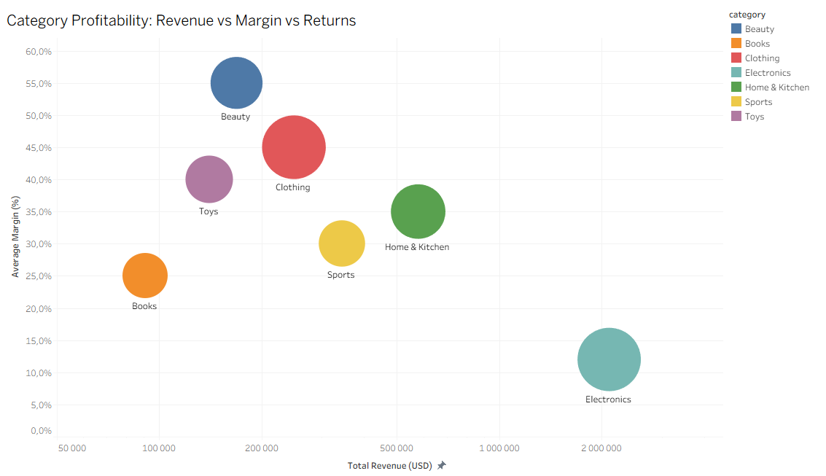
Figure. Category profitability: revenue vs. margin, bubble size = return rate. Electronics sits far right (large revenue) and low (weak margin).
Recommendation
Do not scale Electronics marketing spend or assortment further without addressing margin and returns — for example by tightening return policies on high-return SKUs or renegotiating supplier cost. Treat Electronics as a volume/traffic driver, not a profit driver.

Question 7. Is there a "hidden diamond" — small revenue, excellent margin, low returns? What should be done with it?
Conclusion
Beauty is the hidden diamond. It generates only 4.6% of category revenue, but has the highest margin in the entire catalog (55%) and a below-average return rate (9.97%, versus an 11.1% average across all 7 categories). It is structurally the most profitable category per dollar of revenue, and it is currently under-scaled.
Supporting numbers
- Beauty: $168,624 revenue (4.6% share), 55% margin (highest of all 7 categories), 9.97% return rate (4th-lowest, well below Electronics and Clothing).
- Toys is a secondary candidate: smaller revenue share (3.8%), good margin (40%) and the third-lowest return rate (8.98%), but its margin advantage is smaller than Beauty's.
Recommendation
Beauty deserves deliberate investment: expand the product assortment, increase marketing allocation toward it, and test bundling it with high-traffic categories like Electronics or Home & Kitchen to convert existing traffic into higher-margin baskets.

Case C. Discounts and valuable customers

Question 8. Do customers who buy mostly on discount (average discount over 20%) place more orders and stay, or buy once and disappear, compared to the rest?
Conclusion
Discount-driven customers order less often and are more likely to be one-time buyers. Heavy discounting does not appear to build the kind of repeat relationship the rest of the customer base shows.
Supporting numbers
- Heavy-discount customers (avg. discount > 20%): 352 customers, 2.17 orders on average, $383.72 average total spend, 25.0% are one-time buyers.
- Rest of customers: 2,648 customers, 4.35 orders on average, $1,260.93 average total spend, 16.6% are one-time buyers.
- The gap in order count between the two groups is statistically significant (Welch t-test, p < 0.001).
Recommendation
Stop using deep, blanket discounts as an acquisition tool. If discounts are needed, target them narrowly (clearance, reactivation of lapsed customers) rather than as a default acquisition lever, since they currently correlate with lower-value, less loyal customers.

Question 9. What share of revenue comes from the top 5% of customers? Who are they (region, acquisition channel)? How should the company retain them?
Conclusion
The top 5% of customers (150 people) generate 35.1% of total net revenue — a highly concentrated base. This is consistent with the broader pattern that customers spending above the account average (862 people, 29% of the base) already generate 72.7% of revenue. The highest-value customers are disproportionately acquired through Influencer marketing and are meaningfully over-represented in Southeast Asia relative to that region's share of the overall customer base.
Supporting numbers
- Top 5% of customers (n=150) generate 35.07% of total net revenue; customers above the average spend level (n=862) generate 72.68% of revenue.
- Region mix among top 5%: North America 28.0%, Europe 28.0%, Southeast Asia 25.3%, Latin America 10.0%, Middle East 8.7% — versus an 18.6% base rate for Southeast Asia across all customers, an over-representation of about 7 percentage points.
- Acquisition channel mix among top 5%: Influencer 24.0% (vs. 11.9% base rate — roughly double), Organic 22.7% (in line with its 24.0% base), Social Ads 14.7% (vs. 20.6% base, under-represented), Referral 14.7% (vs. 8.9% base, over-represented), Paid Search 12.7% (vs. 22.2% base, notably under-represented).
- The 10 single largest accounts range from $16,413 to $30,361 in lifetime spend, spanning Europe, North America and Southeast Asia.
Visualization
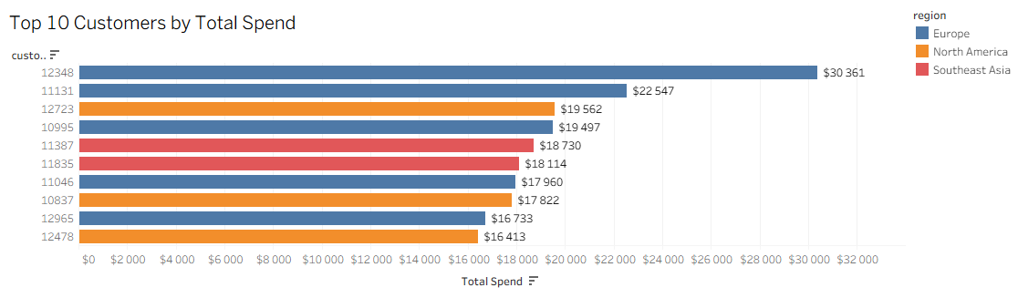
Figure. The 10 largest individual accounts by total spend.
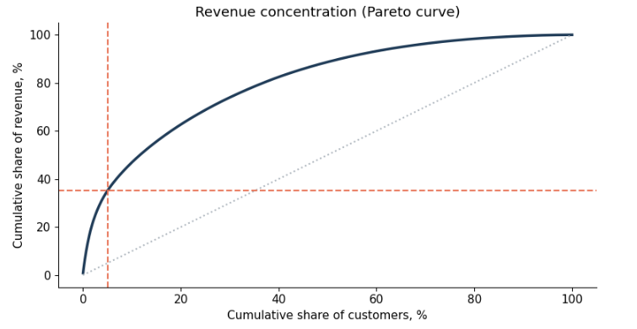
Figure. Revenue concentration curve: cumulative share of customers vs. cumulative share of revenue.
Recommendation
Build a dedicated retention program for this segment: early access to new products, a loyalty tier, or a named account-style relationship for the highest spenders. Because Influencer-acquired and Southeast-Asia customers are over-represented here, prioritize retention investment and continued acquisition spend in exactly those two areas — a direct link to the Case A recommendation.

Checkout redesign: reading the experiment correctly

Question 10. Compare the average order value (net_amount) between groups A and B across all experiment orders. At first glance, does version B look better?
Conclusion
At the aggregate level, version B looks marginally higher, but the difference is small and not statistically significant. Taken at face value, this experiment would be reported as inconclusive.
Supporting numbers
- Group A (old checkout): n = 3,681 orders, mean net_amount = $281.73, std = $359.74.
- Group B (new checkout): n = 3,674 orders, mean net_amount = $287.27, std = $366.72.
- Difference: +$5.54 (+2.0%). Welch t-test: t = -0.654, p = 0.513 — not statistically significant.
Recommendation
Do not conclude anything from the aggregate alone. A non-significant, near-zero effect at the top level does not necessarily mean the redesign has no effect — it means the average, by itself, cannot distinguish a real effect from noise.

Question 11. Split each group into NEW customers (first order within about 60 days of signup) and REPEAT customers. Compare average order value across the four subgroups. What do you see?
Conclusion
The aggregate result was hiding a real, sizeable effect. Version B produces a large, statistically significant increase in average order value for new customers, while having no meaningful effect — if anything, a small, non-significant decrease — for repeat customers.
Supporting numbers
- New customers: A mean = $278.18 (n=758), B mean = $341.47 (n=744). Difference = +$63.29 (+22.8%). Welch t-test p = 0.0031; Mann-Whitney U test p = 0.0004 (confirms the result is not driven by outliers or non-normality).
- Repeat customers: A mean = $282.65 (n=2,923), B mean = $273.51 (n=2,930). Difference = -$9.14 (-3.2%). Welch t-test p = 0.316 — not significant.
- The new/repeat split is balanced across both experiment arms (about 20.6% new in A, 20.3% new in B), so this is a genuine subgroup effect, not an artifact of unequal randomization.
Visualization
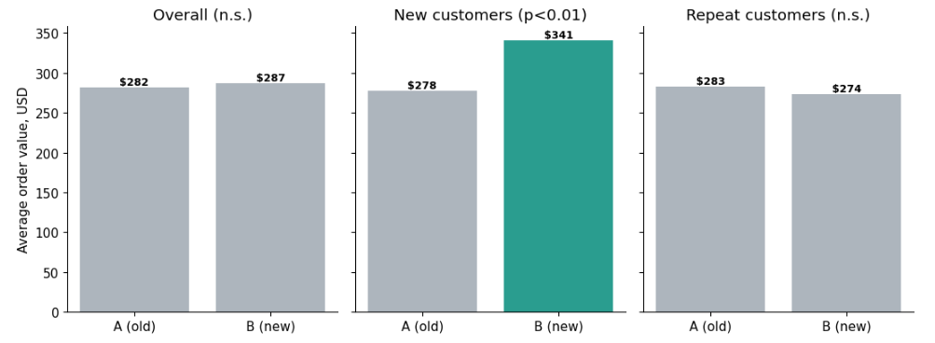
Figure. Average order value by experiment arm: overall (flat), new customers (strong, significant lift), repeat customers (flat).
Recommendation
Report the subgroup results, not just the aggregate. The new-customer effect is large enough and significant enough to act on.

Question 12. For whom should version B be implemented? Can it be turned on for everyone?
Conclusion
Version B should be rolled out to new customers, where it delivers a real, statistically significant lift. It should not be rolled out universally: for repeat customers there is no demonstrated benefit, and forcing a global rollout on the strength of the new-customer result alone would overstate the case.
Supporting numbers
- New customers make up about 20% of orders in this experiment; repeat customers make up about 80%. Because repeat customers are the large majority and show a flat (slightly negative, non-significant) result, their weight in the blended average is what suppresses the aggregate effect down to statistical noise.
- This is the practical lesson: an average computed over a mixed population is a weighted blend of different subgroup effects, and a large, unaffected subgroup can mask a real, valuable effect happening in a smaller one — the mechanism behind Simpson's-paradox-style reversals.
Recommendation
Ship the new checkout experience to new customers. Keep repeat customers on the current experience, or design a separate, targeted test for them — repeat customers may respond to different checkout improvements (e.g. saved-payment speed) rather than the elements that helped new customers (clarity and trust signals).

Question 13. How might the numbers be presented to "sell" version B at any cost — or to "bury" it? How should an honest analyst present the result?
Conclusion
The same dataset supports two misleading narratives and one honest one, depending on which slices are shown and which are omitted.
Supporting numbers
- To "sell" B: report only the new-customer result ("+22.8% average order value, p = 0.003") and omit the overall and repeat-customer numbers, implying the effect applies to all customers rather than one specific segment.
- To "bury" B: report only the aggregate result ("no statistically significant difference, p = 0.51 — the redesign made no difference") and never run the new-vs-repeat breakdown, hiding a real, valuable effect that exists specifically for new customers.
- Both narratives are built from real numbers; both mislead because each omits the subgroup structure that changes the interpretation.
Recommendation
An honest presentation shows all three layers together: the aggregate (flat, not significant), the new-customer subgroup (large, significant lift), and the repeat-customer subgroup (flat, not significant) — with an explanation of why the aggregate conceals the subgroup effect. The recommendation that follows is segmented (roll out to new customers only), not a blanket yes or no.

Recommendations for the CEO
Five recommendations, ranked by expected impact and readiness to act:
1. Reallocate marketing budget away from Paid Search.
Paid Search receives 46% of the marketing budget but has the lowest campaign ROI (1.33x) and the lowest customer LTV ($648). Shift 15-20% of its budget toward Influencer and Referral, which lead on customer LTV ($1,986 and $1,792) and are also over-represented among the top 5% of customers. Phase the shift and track ROI/LTV monthly, since acquisition-channel effects may partly reflect who self-selects into each channel, not only the channel's own power.
2. Treat Electronics as a volume driver, not a profit driver — and scale Beauty deliberately.
Electronics is 57% of category revenue but only 12% margin with one of the highest return rates. Beauty is the opposite: 55% margin, low revenue share, moderate returns. Invest in Beauty's assortment and marketing; work on reducing Electronics' return rate and cost structure rather than growing it further.
3. Rework the discount strategy.
Customers who buy mainly on deep discount (>20%) order half as often and churn more than the rest. Replace blanket acquisition discounting with targeted use cases (clearance, reactivation) and redirect the savings into retention programs for the top 5% of customers, who already generate 35% of revenue.
4. Roll out the new checkout experience to new customers now.
It delivers a real, statistically significant 22.8% increase in average order value for customers within their first 60 days. Do not roll it out to repeat customers yet — no benefit was demonstrated for them; design a separate test for that segment.
5. Standardize subgroup analysis and validation before numbers reach leadership.
The A/B result would have been reported as "no effect" without splitting by customer type. Separately, two calculation issues were caught and corrected during this analysis: an integer-division error that distorted channel ROI, and a numerator/denominator mismatch that inflated category return rates. Both argue for a standard checklist — segment key results, and sanity-check every aggregate ratio — before any number is presented to the board.

